
FANNIN COUNTY
REQUEST FOR PROPOSALS
RFP # 2026-003
JANITORIAL SERVICES
SUBMITTAL DEADLINE:
Thursday June 18, 2026 Before 3:00 PM
FANNIN COUNTY
PURCHASING AGENT’S OFFICE
101 E. SAM RAYBURN DR.
SUITE 313
BONHAM, TX 75418
(903) 583-0054

The enclosed REQUEST FOR PROPOSAL and accompanying SPECIFICATIONS are for your convenience in submitting an offer for the enclosed referenced JANITORIAL SERVICES.
----------------------
The Commissioners Court of Fannin County, TX reserves the right to accept or reject any/or all proposals as it shall deem to be in the best interest of Fannin County. Receipt of any proposal shall under no circumstances obligate Fannin County to accept the lowest proposal. The award of the contract or contracts shall be made to one or more responsible contractor or contractors whose proposal is determined to be the most attractive to Fannin County, resulting from negotiation, taking into consideration the relative importance of price and other evaluation factors set forth in the request for proposal.
Proposals shall include this RFP and all additional documents submitted. Each proposal shall be placed in a separate sealed envelope, manually signed in ink by a person having the authority to bind the firm in a contract and marked clearly on the outside as outlined below.
SUBMISSION OF PROPOSALS
One (1) original and three (3) copies of all proposal documents shall be sealed and submitted as contractor’s response to:
FANNIN COUNTY
PURCHASING AGENT
Lee Swafford
101 E. SAM RAYBURN DR.
SUITE 313
BONHAM, TX 75418
(903) 583-0054
SUBMITTALS MUST BE FILED IN THE COUNTY PURCHASING AGENT OFFICE BEFORE 3:00 PM THURSDAY, JUNE 18, 2026
Label envelope: RFP # 2026-003 JANITORIAL SERVICES
SUBMITTALS SHALL BE OPENED AT 3:15 PM THURSDAY, JUNE 18, 2026 IN THE FANNIN County PURCHASING AGENT’S OFFICE, 101 E. SAM RAYBURN DR. SUITE 313, BONHAM, TX 75418

SELECTION AND AWARD PROCESS
Fannin County uses a two-step process for the final selection or selections for awarding the Janitorial service proposal.
Step 1 consists of a Qualifications package to be submitted by Janitorial companies interested in being considered. The County may select up to three (3) short-listed companies based on evaluation of the written materials submitted. Short-listed companies may be asked to submit additional information.
Step 2 consists of the election of one or more finalist’s following interviews with the short-listed companies. The County initiates negotiations with the selected company or companies. If negotiations are unsuccessful, the County enters into the process with the next highest ranked short-listed company. Any contract is subject to the approval of the Commissioners Court.
NO INDIVIDUAL OF ANY COUNTY DEPARTMENT HAS THE AUTHORITY TO LEGALLY AND/OR FINANCIALLY COMMIT THE COUNTY TO ANY CONTRACT, AGREEMENT OR PURCHASE ORDER FOR GOODS OR SERVICES, UNLESS SPECIFICALLY SANCTIONED BY THE REQUIREMENTS OF THE REQUEST FOR PROPOSAL.
ADDENDA TO THE REQUEST FOR PROPOSAL
Requests for interpretations and clarifications of the RFP may only be made in writing. All requests must be submitted in writing to Lee Swafford, Purchasing Agent, at purchasing@fanninco.net.
It shall be the responsibility of each vendor, prior to submitting the competitive proposal, to check the website to confirm if addenda were issued and to make such addenda a part of the competitive proposal.
LATE PROPOSALS
Proposals received in the Purchasing Office after submission deadline shall be returned unopened and will be considered void and unacceptable. Fannin County is not responsible for lateness of mail, carrier, etc. The Purchasing Office shall be the official time of receipt.
ALTERING PROPOSALS
Any interlineation, alteration, or erasure made before receiving time must be initialed by the signer of the proposal, guaranteeing authenticity.
WITHDRAWAL OF PROPOSAL
A proposal may not be withdrawn or cancelled by the contractor for a period of ninety (90) days following the date designated for the receipt of proposal, and contractors so agree upon submission of their proposal.

PROPOSAL OPENING
Proposals will be received and publicly acknowledged at the location, date, and time stated above. Contractors, their representatives, and interested persons may be present. The proposals shall be received and acknowledged so as to avoid disclosure of the contents to competing contractors and kept secret during negotiations. All proposals shall be open for public inspection after the contract is awarded, except for trade secrets and confidential information contained in the proposal and identified by the contractor as such.
SALES TAX
Fannin County, Texas is by statute exempt from the state sales tax and federal excise tax; therefore, the proposal price shall not include taxes.
CONFLICT OF INTEREST
No public official or Fannin County employee shall have interest in this contract, in accordance with Vernon, Texas Codes Annotated, Local Government Codes Title 5, Submitted C, Chapter 171.
INTRODUCTION
Fannin County is soliciting sealed proposals from qualified vendors for Janitorial services for various owned and leased facilities.
The County desires to receive proposals limited to the following ten (10) facilities: #1) The Fannin County Courthouse, #2) The Derrell Hall Education Center, #3) The South Annex which houses District Court and Tag Office, #4) District Clerk’s offices, #5) The East Annex, #6) County Clerk and District Attorney’s office, #7) The Justice of the Peace, Pct.3 - Windom Building, #8) Sheriff’s Office, #9) The Justice of the Peace, PCT 2 – Leonard and #10) Fannin County Justice Center.
The District Clerk’s Office, #4, and the County Clerk and District Attorney’s Office, #6, will be bid on a week to week bid as they will be moving to the Justice Center upon its completion.
SCHEDULE FOR SELECTION PROCESS
The following projected dates are set forth for your knowledge and understanding:
• Fannin County begins the RFP Process on June 2, 2026
• A Pre-Bid Conference will be held June 9, 2026 at 9:30 AM
• Written questions must be directed to Lee Swafford at purchasing@fanninco.net. Questions related to definitions or interpretations of the RFP must be submitted in writing on or before June 12, 2026
• Proposals are due no later than June 18, 2026 at 3:00 PM
• Proposals will be opened June 18, 2026 at 3:15 PM
• A Screening Committee will meet with candidates June 25, 2026 at 2:30 PM and the Commissioners Court will follow up with the Screening Committees decision on or before July 21, 2026.

RIGHT OF COUNTY TO CANCEL REQUEST FOR PROPOSALS, TO ELECT NOT TO AWARD, TO REJECT SUBMITTALS, AND TO WAIVE INFORMALITIES OR IRREGULARITIES
I. PROPOSAL TERMS
• The Commissioners Court of Fannin County reserves the right to reject any and all proposals received as a result of this RFP. If one or more proposals are selected, it will be the most advantageous regarding price, quality of service, the independent contractor's qualifications, and capabilities to provide the specified service, and other factors, which may be considered in the best interest of the County. The County does not intend to award a contract fully based on any response made to the proposal. The County reserves the right to consider proposals for modifications at any time before a contract would be awarded, and negotiations would be undertaken with the independent contractor or contractors whose proposal is deemed to best meet the County’s specifications and needs.
• Proposals must be signed by an official authorized to bind the independent contractor to its provisions for a period of no less than (90) days. Failure of the successful bidder to accept the obligation of the contract may result in the cancellation of any award.
• In the event it becomes necessary to revise any part of the RFP, addenda will be provided. The deadline for submission of proposals may be adjusted to allow for revisions. To be considered, the entire proposal document, with any amendments, should be returned by the specified date, time and method identified on page 1 of this document.
• Proposals should be prepared simply and economically providing a straightforward, concise description of the independent contractor's ability to meet the requirements of the RFP. Proposals shall be written in ink or typewritten. No erasures are permitted. Mistakes may be crossed out and corrected and must be initialed in ink by the person signing the proposal.
• The price quotations from the contractor stated in this proposal will not be subject to any price increase from the closing date of this RFP to the mutually agreed to date of contract. It is anticipated that if a contract is awarded for these services that services will begin on August 1, 2026.
• Fannin County reserves the right to increase or decrease the amount of janitorial services based upon annual budget constraints with fifteen (15) days’ notice.
• Fannin County reserves the right to award a separate contract to separate vendors for each item/group or to award one or more contracts for the entire RFP.
• During the contract term Fannin County reserves the right to add or remove locations as determined necessary by the County with fifteen (15) days’ notice. If locations are modified the contract pricing may be adjusted accordingly.
II. PRE-BID CONFERENCE
A non-mandatory Pre-Bid Conference will be held at 9:30 a.m. on June 9, 2026 at the Courthouse, 101 E. Sam Rayburn Dr, Bonham, Texas in the 2nd floor conference room. All interested parties will have an opportunity to be given a tour of the ten (10) buildings within the scope of this agreement. Proposers not in attendance may not have another opportunity to view buildings.
III. PROPOSAL SPECIFICATIONS
Please provide the following information as attachments:
• Independent contractor’s qualifications
• Years in business
• Experience providing the level and type of service specified in the RFP.
• Three (3) current references of janitorial service agreements covering similar services listed in the proposal. Include company name, contact name, phone number and email address. Note: Government references are preferred.
IV. EVALUATION CRITERIA
The following criteria will be used by some County employees to evaluate the proposals and make a selection:
❖ 10% Qualifications of key personnel – Cleaning and supervisory staff duly qualified, capable and bondable to fulfill and abide by specifications. All staff must pass a background check.
❖ 20% Experience – Experience in janitorial services, including years and history
❖ 10% Reference – Respondents shall provide a minimum of three (3) current references of janitorial service agreements covering similar services listed within this proposal packet.
❖ 30% Fee schedule/cost of service
❖ 20% Project/Service approach
❖ 10% Supplies – Quality of cleaning supplies based on submittal of
manufacturers and samples, if applicable
County staff may choose to meet with the top-rated offerors. Any additional information requested shall be considered as part of the proposal and evaluated as such. Fannin County reserves the right to negotiate a best and final offer with the selected vendor.
V. STANDARD CONTRACT PROVISIONS
Should a contract be awarded, the selected contractor or contractors will be required to adhere to a set of general contract provisions that will become a part of any formal agreement. The following is a summary of the general terms and contract provisions that apply to all independent contractors of service to Fannin County.
A. GENERAL TERMS – INDEPENDENT CONTRACTOR RESPONSIBILITIES
1. The independent contractor is to report to the County’s designated representative and will cooperate and confer with him/her as necessary to insure satisfactory work progress.
2. All reports, estimates, memoranda and documents submitted by the independent contractor must be dated and bear the independent contractor's name and be submitted to the County’s designated representative.
3. All reports made in connection with these services are subject to review and final approval by the County’s designated representative.
4. The County may review and inspect the independent contractor's activities during the term of this contract.
5. If applicable, the independent contractor shall submit a final, written report to the County’s designated representative.
6. After reasonable notice to the independent contractor, the County may review any of the independent contractor's internal records, reports, or insurance policies.
7. The independent contractor will provide the required services personally and will not subcontract or assign the services without the County’s prior written approval.
8. The independent contractor will not hire any County employee for any of the required services without the County’s prior written approval.
9. All employees hired by the independent contractor must pass a background check before completing any scope of work for the county.
10. The Independent contractor has the right to hire employees as needed. Independent contractor employees working at the Fannin County Sheriff’s Office will need to clear a background check by the Fannin County Sheriff’s Office before being permitted to work at the Fannin County Sheriff’s Office. Each employee’s legal name, address and driver’s license number must be submitted to the County Judge, upon request, where a criminal background check will be completed prior to receiving access to any of the County’s buildings.
11. The parties agree that the independent contractor is neither an employee nor an agent of the County for any purpose.
B. INDEMNIFICATION/HOLD HARMLESS AGREEMENT
The contractor agrees to indemnify and save harmless the County and its officers and employees from all claims and liability due to activities of itself, its agents, or employees, performed under this contract and which are caused by or result from error, omission, or negligent act of the Provider or of any person employed by the contractor. The contractor shall also indemnify and save harmless the County from any and all expense, including, but not limited to, attorney fees which may be incurred by the County in litigation or otherwise resisting said claim or liabilities which may be imposed on the County as a result of such activities by the contractor or its employees. The contractor further agrees to indemnify and save harmless the County from and against all claims, demands, and causes of action of every kind and character brought by any employee of the contractor against the County due to personal injuries and/or death to such employee resulting from any alleged negligent act by either commission or omission on the part of the contractor.
C. INSURANCE REQUIREMENTS
Any successful offeror shall be required to show evidence of Comprehensive General Liability Insurance and Automobile Liability Insurance with Fannin County, Texas, listed as additional named insured. Any successful offeror shall also be required to carry Workers' Compensation Insurance in full compliance with the laws of the State of Texas.

The successful bidder shall furnish certificates of insurance as outlined below:
A. Certificates of Insurance
1. Shall furnish certificates of insurance issued by an insurance company authorized to do business in the State of Texas and who have consistently maintained an AM Best Rating of A-, A, A+ or A++ since January 1, 2003. The certificate shall provide that the coverage not be reduced or cancelled without thirty (30) days advance written notice to Fannin County, Purchasing Office, 101 E. Sam Rayburn Drive, Suite 313 Bonham, TX 75418.

2. The certificate of insurance and the underlying insurance policies shall name Fannin County as an additional insured.
B. Insurance Policy Limits Requirements
1. Shall provide comprehensive general liability insurance and comprehensive automobile liability insurance, each policy having limits no less than One Hundred Thousand and no/100 ($100,000.00) Dollars per claimant / Three Hundred Thousand and no/100 ($300,000.00) Dollars / per occurrence; Three Hundred Thousand and no/100 ($300,000.00) Dollar’s aggregate; of Three Hundred Thousand and no/100 ($300,000.00) Dollars combined limits.

2. In addition to the insurance policies required in Paragraph B(1), above, shall also provide an excess liability policy of insurance with limits no less than One Million and no/100s ($1,000,000.00) Dollars.

C. Coverage’s Required in Comprehensive General Liability Insurance Policies.
1. The comprehensive general liability insurance policy shall include coverage for the following:
a. Premises operations
b. Independent contractors
c. Products / completed operations
d. Personal injury
e. Advertising injury
f. Contractual liability
g. Medical payments
h. Underground hazard
i. Explosion and collapse hazard
2. The comprehensive general liability insurance policy shall name Fannin County as an additional insured.
D. Coverages Required in Comprehensive Automobile Liability
The contractor shall provide comprehensive automobile liability insurance, including coverage for loading and unloading hazards, and for owned/leased vehicles.
D. BOND
Each proposer must submit a bid bond or cashier’s check for five percent (5%) of the total amount bid. Once the RFP is awarded, the successful vendor must submit a performance and/or payment bond for the full amount of the award prior to commencement of work.
E. COMPLIANCE WITH LAWS AND REGULATIONS
The independent contractor will comply with all federal, state, and local regulations, including, but not limited to, all applicable OSHA/MIOSHA requirements and the Americans with Disabilities Act.
F. INTEREST OF INDEPENDENT CONTRACTOR AND FANNIN COUNTY
The independent contractor promises that it has no interest that would conflict with the performance of this contract. No officer, agency, employee of Fannin County, or member of its governing body, may participate in any decision relating to this contract which affects his/her personal interest or the interest of any corporation, partnership or association in which he/she is directly or indirectly interested, or has any personal or pecuniary interest.
G. CONTINGENT FEES
The independent contractor promises that it has not employed or retained any company or person, other than bona fide employees working solely for the independent contractor, to solicit or secure this contract, and that it has not paid or agreed to pay any company or person, other than bona fide employees working solely for the independent contractor, to solicit or secure this contract and that it has not paid or agreed to pay any company or person, other than bona fide employees working solely for the contractor, any fee, commission, percentage, brokerage fee, gifts or any other consideration contingent upon or resulting from the award or making of this contract. For breach of this promise, the County may cancel this contract without liability or, at its discretion, deduct the full amount of the fee, commission, percentage, brokerage fee, gift, or contingent fee from the compensation due the independent contractor.

H. EQUAL EMPLOYMENT OPPORTUNITY
The independent contractor will not discriminate against any employee or applicant for employment because of race, creed, color, sex, sexual orientation, national origin, physical handicap, age, height, weight, marital status, veteran status, religion or political belief (except as it relates to a bona fide occupational qualification reasonably necessary to the normal operation of the business). The independent contractor agrees to post notices containing this policy against discrimination in conspicuous places available to applicants for employment and employees. All solicitations or advertisements for employees, placed by or on behalf of the independent contractor, shall state that all qualified applicants shall receive consideration for employment without regard to race, color, creed, sex, sexual orientation, national origin, physical handicap, age, height, weight, marital status, veteran status, religion, or political belief.
I. EQUAL ACCESS
The independent contractor shall provide the services without discrimination based on race, color, religion, national origin, sex, sexual orientation, marital status, physical handicap, or age.
J. OWNERSHIP OF DOCUMENTS AND PUBLICATION
As a result of this contract, all documents developed will be freely available to the public; none may be copyrighted by the independent contractor. During the performance of the services, the independent contractor will be responsible for any loss of or damage to the documents while they are in its possession and must restore the loss or damage at its expense. Any use of the information and results of this contract by the independent contractor must reference the project sponsorship by Fannin County. Any publication of the information or results must be co-authored by the County.
J. ASSIGNS & SUCCESSORS
This contract is binding on the County and the independent contractor, their successors and assigns. Neither the County nor the independent contractor will assign or transfer its interest in this contract without the prior written consent of the other.
K. TERMINATION OF CONTRACT
In cases of termination without cause, either party may terminate the contract by giving thirty (30) days written notice to the other party.
L. PAYROLL TAXES
The independent contractor is responsible for all applicable state and federal social security benefits and unemployment taxes and agrees to indemnify and protect the County against such liability.
M. CHANGES IN SCOPE OR SCHEDULE OF SERVICES
Changes mutually agreed upon by the County and the independent contractor will be incorporated into this contract by written amendments signed by both parties.
N. CHOICE OF LAW AND FORUM
This contract is to be interpreted by the laws of Texas. The parties agree that the proper forum for litigation arising out of this contract is Fannin County, Texas.

O. EXTENT OF CONTRACT
This contract represents the entire agreement between the parties and supersedes all prior representations, negotiations, or agreements, whether written or oral.
VI. TERMS AND SPECIAL CONDITIONS
A. TERM OF CONTRACT
The initial term of the contract shall be for the ten (10) facilities outlined in this RFP for a 12-month period beginning August 1, 2026 and ending July 31, 2027. Upon the conclusion of this initial 12 months, the County, at its option may terminate this contract, or may choose to extend the contract for a one (1) year period. Thereafter, the contract may be extended for all of the County’s facilities for two (2) additional one (1) year periods under like terms and conditions. Notice of intent to renew would be issued in writing by Fannin County thirty (30) days prior to the expiration dates of the contract.
B. EQUIPMENT, SUPPLIES, AND MATERIALS
The independent contractor will provide all necessary equipment required in order to perform the services of this contract. Such equipment shall be approved by the County. The contractor is responsible for keeping the equipment safe and operable at all times.
The County will supply electrical power, hot and cold water, hand soap for designated dispensers, toilet paper, paper towels, and in-office receptacle plastic bags used for the collection of trash. The contractor must maintain a record of the supplies used from the County’s stock inventory and request replacement products quarterly from the County’s Purchasing Department in writing allowing at least 30 days for receipt of order.
The contractor will provide all other cleaning material and supplies for the satisfactory cleaning of the facilities. All cleaning products shall be compatible with the building materials. Compatibility shall be determined by the manufacturer’s recommendations, and approved by the County. No additional charges shall be made for these items.
C. INITIAL CLEANING REQUIREMENT
The contractor, in addition to the initial month’s services, shall bring all facilities up to contract standards during the first month of the contract. This initial cleaning will be in addition to routine cleaning tasks, but will not be billable as additional work performed. The contractor, his/her supervisor(s), and the County’s designated representative will meet prior to the first week of the contract to ensure that the facilities will meet the contract standards. Failure to successfully complete this initial phase may be a determining factor for withholding payment until standards are met or terminating the contract.
D. PERSONNEL QUALIFICATIONS
The contractor shall have an active, experienced, trained, competent, and reliable employee, with supervisory control dedicated to the County facilities during contract hours to supervise the janitorial services provided hereunder; and he/she shall be authorized to represent and act for the contractor. All supervisors must be fluent in English and have an intimate knowledge of the various cleaning tasks, equipment, and materials, so as to be able to maintain and control an effective Quality Control Program.
E. SCHEDULING AND ACCESS TO BUILDING
Access to the buildings shall be as directed by the County. Contractor’s employees are not to be accompanied in their work areas on the premises by any other person (adult or minor) unless said persons are authorized contractor employees. The contractor shall be responsible for all persons admitted to the facility by the contractor, its officers, agents, or employees. The contractor shall establish procedures to ensure that all building spaces are secured as required by the County.
The contractor shall schedule all required services so as not to interfere with County operations. All County Offices are open from 8:00 am to 5:00 pm, Monday through Friday. Contractor’s work shall be accomplished during building non-use hours except for the District Attorney/County Clerk Building, Sheriff’s Office and Justice of the Peace, PCT 2. Those four offices will be cleaned during business hours. Refer to Section VIII. FACILITIES LISTING for each facility's operating hours and exceptions. Variances in schedules shall require prior approval of the County’s designated representative.
F. BILLING AND PAYMENTS
The contractor shall submit a monthly invoice by the 10th of each month for the prior month’s work. Invoices shall be mailed to:
Fannin County
Accounts Payable
101 E. Sam Rayburn Drive
Suite 302
Bonham, TX 75418
Or emailed to:
ap@fanninco.net
Payment from the County for work performed in accordance with the contract shall be due thirty (30) days from receipt of the monthly invoice. The County may withhold any payment or partial payment otherwise due the contractor as a result of unsatisfactory performance by the contractor. The amount shall be withheld until such work is corrected.
VII. CLEANING SPECIFICATIONS FOR FANNIN COUNTY FACILITIES
COMMON AND PUBLIC AREAS
The following tasks will be performed at all facilities:

A. DAILY TASKS
1. Sweep, pick up and dispose of debris in entry approach areas
2. Vacuum all entry mats
3. Vacuum carpeted traffic (open) areas in all offices; spot treat spills/soiled areas and remove gum
4. Dust mop/damp mop all hard surface flooring (including hallways and restrooms)
5. Damp wipe and disinfect drinking fountains
6. Damp wipe clear conference tables and countertops
7. Empty all waste and recycle receptacles into appropriate collection containers
8. Spot clean doors and walls, as needed
9. Clean both sides of entry door glass; dry frames
10. Clean all sinks and countertops
11. Clean and disinfect restrooms:
a. Ceramic tile floor – sweep and mop with germicide
b. Floor drains – remove litter from screens, seal traps
c. Wall surfaces – remove spots with germicide
d. Hand sinks – clean with germicide; scour if needed
e. Countertop surfaces – clean with germicide and dry
f. Mirrors – clean with glass cleaner and dry
g. Commodes – clean entire fixture with germicide; brush interior under flush rim; dry exterior, seat and polish plumbing
h. Urinals – clean entire fixture with germicide; brush interior under flush rim; dry exterior, seat and polish plumbing
i. Stall partitions – clean with germicide and dry
j. Trash receptacles – empty (reline if soiled) and reposition; damp wipe with germicide
k. Hand soap dispensers – refill, unplug nozzle and clean with germicide
l. Paper towel dispensers – refill, clean with germicide and dry
m. Toilet tissue dispensers – refill, clean with germicide and dry
n. Sanitary napkin receptacle – empty, reline with waxes bag liner; clean interior and exterior with germicide
o. Fog buildings. Use County provided fogging machine and disinfectant solution.

B. WEEKLY TASKS
1. Clean both sides of glass, including sidelight glass, hall glass and office/partition glass, dry frames

2. Dust:
Window blinds and ledges, spot clean interior windows
Dust/damp wipe file cabinets, wall shelving and bookshelves
Wall decorative items
Coat racks
Plant and plant containers
3. Vacuum all carpeted areas including seating areas, around and under desks including edge work, perform detail vacuum
4. Scrub restrooms
5. Clean baseboards
6. Refill hand sanitizer stations
C. MONTHLY TASKS
1. Damp cloth cleaning of all desks/workstations, based on predetermined schedule established through the County’s designated representative
2. Dust office machines (copiers, fax machines, shredders, etc.)
3. Dust courtrooms and stair railings at the Courthouse
3. Clean light fixtures (open fluorescent type to remove bugs) in ceilings less than ten (10)
feet high
4. Clean interior and exterior of trash receptacles
5. Clean all interior upper glass
6. Wipe down elevators (clean off fingerprints)
7. Mop Courthouse stairs and Courthouse wood floors twice a month
Carpet Cleaning, Wax Stripping and other items that are needed periodically will be discussed with the Contractor and priced separately from this RFP.
VIII. FACILITY LISTING AND COST PROPOSALS
The County facilities listed below are covered in this RFP. The list below identifies the location, service frequency, special janitorial needs (in addition to the daily, weekly, monthly and yearly tasks identified in Section VII. Cleaning Specifications for Common and Public Areas) and other relevant comments for each facility. The contractor will propose the total cost per month (daily, weekly, monthly, and additional tasks combined) for each facility. The costs per location will be used to calculate an overall budgetary total and compare proposals.
1. SOUTH ANNEX- 210 S. MAIN STREET
336TH DISTRICT COURT
TAG OFFICE
This facility houses the District Court and The Tag Office and is frequented by several members of the public every day. Cleaning cannot commence until the Court is concluded. There are 2 restrooms in the courtroom area and one in the Tag Office. The Men's Restroom has one stall and one urinal and a sink. The women's restroom has two sinks, and 5 stalls. The Tag Office restroom has one stall. The Tag Office has a kitchen area. The courtroom is to be vacuumed and dusted on a regular basis. The upstairs to this facility is not included in this scope of work.
Please propose this facility at both a daily clean (5 days) and (3 days) per week.
Total Cost per Month (daily, weekly, & monthly tasks combined): ____________(5days)
Total Cost per Month (daily, weekly, & monthly tasks combined): ____________ (3 DAYS)
2. EAST ANNEX-1203 E. SAM RAYBURN DR
JUVENILE PROBATION
DPS (DRIVER’S LICENSE)
MISC COUNTY OFFICES (5)
This facility experiences a lot of traffic and needs to be cleaned daily. There are two bathrooms, each with two stalls and a sink. There is a small kitchen area with a sink and a conference room in addition to the offices. There is a front lobby.
Please propose this facility at both a daily clean (5 days) and (3 days) per week
Total Cost per Month (daily, weekly, & monthly tasks combined): ____________ (5 DAYS) Total Cost per Month (daily, weekly, & monthly tasks combined): ____________ (3 DAYS)

3. DISTRICT ATTORNEY/
COUNTY CLERK
800 EAST 2ND STREET
This facility provides offices for the District Attorney Staff and the County Clerk's staff. There are two restrooms, the women’s restroom has 2 stalls, and the men's has 2 stalls and a urinal. There is a conference room and a kitchen area.
Please propose this facility at both a daily clean (5 days) and (3 days) per week.
Total Cost per Month (daily, weekly, & monthly tasks combined): ____________ (5 DAYS) Total Cost per Month (daily, weekly, & monthly tasks combined): ____________ (3 DAYS)
4. COUNTY OFFICES (DISTRICT CLERK)
200 EAST 1ST STREET
This facility has two restrooms consisting of two toilets, a urinal and three sinks. There is a small kitchen area with one sink. Cleaning the adjacent warehouse is not part of this RFP. There is one conference room, a lobby and several offices.
Please propose this facility at both a daily clean (5 days) and (3 days) per week.
Total Cost per Month (daily, weekly, & monthly tasks combined): _________ (5 DAYS) Total Cost per Month (daily, weekly, & monthly tasks combined): __________ (3 DAYS)
5. JUSTICE OF THE PEACE, PCT. 3
711 STATE HWY 56 - WINDOM
This facility has two restrooms consisting of 2 toilets and 2 sinks, a lobby area, offices and a court area. There is a small kitchen area with one sink. Also 1 water fountain and 1 deep sink (cleaning) in the back. Please propose this facility at a clean 2 times per month.
Total Cost per Month (daily, weekly, & monthly tasks combined): ___________ (2X a MONTH)
6. DERRELL HALL EDUCATION CENTER
2505 N. CENTER STREET
This facility has a large conference/meeting area, a kitchen, two restrooms and offices. At times, the facility is used evenings and on weekends for special meetings. The county will notify the contractor of schedule conflicts. This facility only requires cleaning three times a week unless contractor is advised differently and compensated.
Total Cost per Month (daily, weekly, & monthly tasks combined): ____________ (3 DAYS)

7. COURTHOUSE
101 E. SAM RAYBURN DRIVE
This 3-story facility provides offices for several departments. 1st floor consists of 6 offices, a courtroom, jury room, mail room and two restrooms consisting of 5 toilets, 2 urinals and 3 sinks; and 2 water fountains by the elevator. 2nd floor consists of 3 offices, a large courtroom, conference room, breakroom with 1 sink and restrooms two restrooms consisting of 2 toilets and 2 sinks. 3rd floor consists of 5 offices, courtroom balcony and 1 restroom with 1 toilet and 1 sink; there are 2 water fountains by the elevator.
Total Cost per Month (daily, weekly & monthly tasks combined): __________________________
(1st floor - 3 days per week, 2nd floor - 2 days per week, 3rd floor - 1 day per week)
8. SHERIFF’S OFFICE
2375 SILO ROAD
This facility will need the following: Dusting of offices and public areas, trash removal in offices/public areas/break area/restrooms. Disinfect/clean five bathrooms, including toilets, sinks, showers (where applicable) and floors. Disinfect/clean break area and floors. Sweep/mop/vacuum flooring for all offices, hallway, entry way and reception area. Restock restrooms/break area with supplies. Maintain inventory (including submission of orders for new/restocking of supplies) has five restrooms.
The Sheriff’s office will need to be cleaned on Monday and Friday and cleaning needs to start at 8:00am.
Restricted offices (such as the Armory/Evidence room) will not be cleaned by Janitorial staff.
Total Cost per Month (daily, weekly, & monthly tasks combined): ___________ (2X a WEEK)
9. JUSTICE OF THE PEACE, PCT 2
111 W. COLLINS, LEONARD, TX 75452
This facility has no restrooms. 2 offices, small entry way and file area. This office will need minimal vacuuming, sweeping, mopping, dusting, glass cleaning and garbage removal. Approximately 350 sq feet. Cleaning must occur during business hours (M-F 8:00am-5:00pm). Propose this facility at a clean 2 times per month.
Total Cost per Month (daily, weekly, & monthly tasks combined): ___________ (2X a MONTH)
10. Fannin County Justice Center
2225 North Center Street
This facility will be approximately 45,000 square feet with several offices, two court rooms, break rooms, storage areas and multiple bathrooms. Completion date of the Justice Center is between June and July 2026. This facility will need to be cleaned 5 days a week. The time of day and the frequency of cleaning could change as the needs are accessed.
Total Cost per Month (daily, weekly, & monthly tasks combined): ___________ (Daily)

AUTHORIZED SIGNATURE
Signature and Date Company Name
Print Name Company Address
Title County, State, and Zip Code

Telephone Number Fax Number
Federal Tax ID Number Email Address
The above individual must be authorized to sign on behalf of the company submitting the proposal. Proposals must be signed by an official authorized to bind the provider to its provisions for at least a period of ninety (90) days.
Disclosure of Interested Parties
Form 1295

House Bill 1295, adopted by the 84th Legislature, created §2252.908, Texas Government Code. Section 2252.908 requires a business entity entering into certain contracts with a governmental entity or state agency to file with the governmental entity or state agency a disclosure of interested parties at the time the business entity is awarded the contract to the governmental entity or state agency.

§2252.908, Texas Government Code requires the commission to adopt rules necessary to implement the new disclosure requirement and to prescribe the disclosure form. Section 2252.908 requires the disclosure form to be signed by the authorized agent of the contracting business entity, acknowledging that the disclosure is made under oath and under penalty of perjury. Section 2252.908 applies only to a contract that requires an action or vote by the governing body of the governmental entity or state agency before the contract may be signed or has value of at least $1 million. Section 2252.908 provides definitions of certain terms occurring in the section. House Bill 1295 provides that §2252.908 applies only to a contract entered into on or after January 1, 2016.

An interested party is defined as a person who has a controlling interest in a business entity with whom a governmental entity or state agency contracts or who actively participates in facilitating the contract or negotiating the terms of the contract, including a broker, intermediary, advisor, or attorney for the business entity.

Contractors are required to acquire Form 1295 via the Texas Ethics Commission website. This requires registration, generation of Form 1295 with a unique Certificate Number & filing date, printing the form, signing and returning the form to the Fannin County Purchasing Department. Once the form is received by the Purchasing and Contract Department, the Buyer associated with the project will log-in to the Texas Ethics Commission Portal and acknowledge the receipt of the form not later than the 30th day after the date of the contract for which the form was filed binds all parties to the contract. This will complete the form for the contract with which the form is associated. The completed form will be made available via the Texas Ethics Commission website.

Additional Terms and Conditions:

Pursuant to Government Code 2252.908 in regards to HB 1295 Filing of application of Certificate of Interested Parties (Form 1295) shall be completed after proposal has been awarded. Below is a link to the State of Texas Ethics Commission Form 1295 Certificate of Interested Parties Electronic Filing Application:

https.//prd.tecprd.ethicsefile.com/file
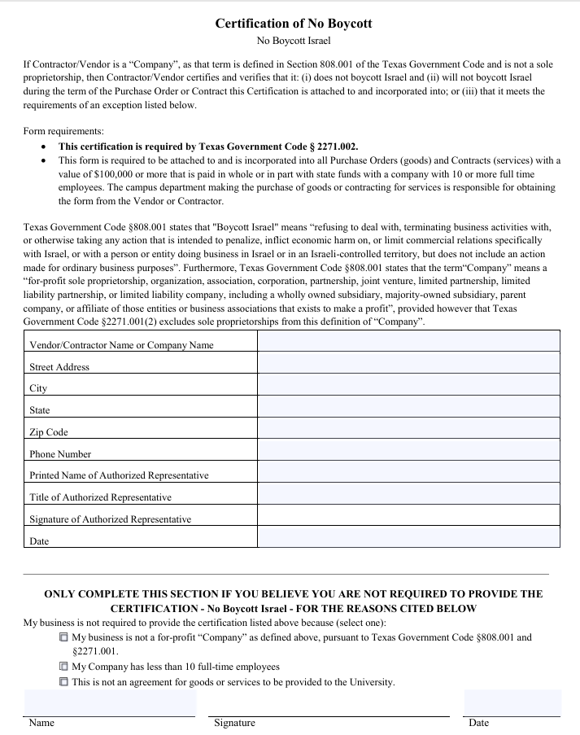
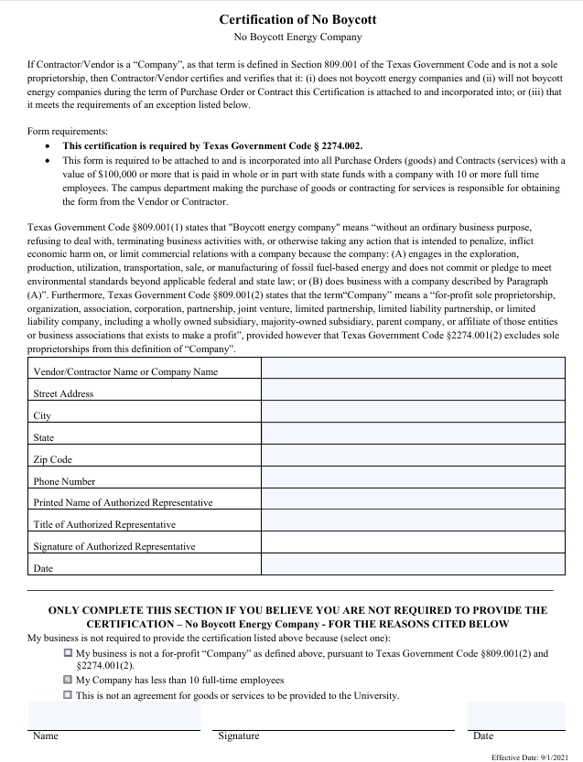

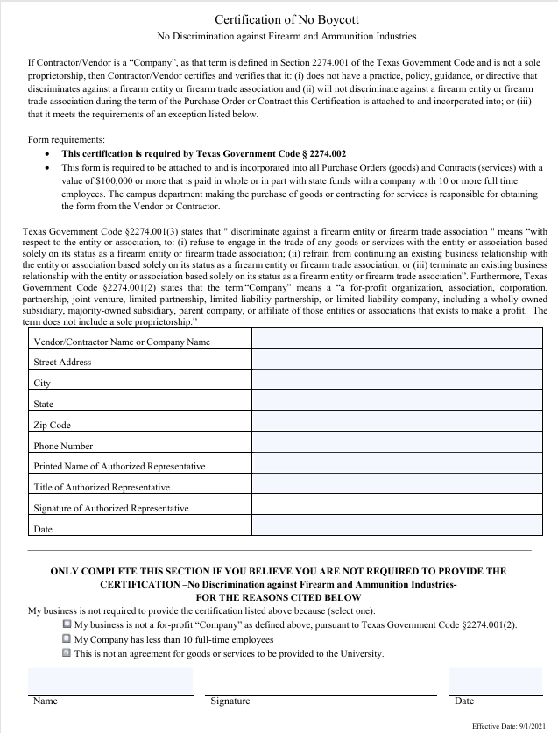

NO FACSIMILE TRANSMITTALS SHALL BE ACCEPTED.

FUNDING: Funds for payment have been provided through the Fannin County budget approved by the Commissioners Court for this fiscal year. State of Texas statues prohibit the obligation and expenditure of public funds beyond the fiscal year for which a budget has been approved. Therefore, anticipated orders or other obligations that may arise past the end of the current Fannin County fiscal year shall be subject to budget approval.

COOPERATIVE PURCHASING: Other governmental entities may wish to also participate under this contract (piggyback). Each entity wishing to piggyback must have prior authorization from Fannin County and the successful bidder. If such participation is authorized, all purchase orders will be issued directly from and shipped directly to the entity requiring materials. Fannin County shall not be held responsible for any orders placed, deliveries made or payment for materials ordered by these entities. Bidder is requested to state whether they will be will be willing to allow other governmental entities to piggyback off this contract, is awarded, under the same terms and conditions in the space provided.

LATE BIDS: Bids received in County Purchasing Agents office after submission deadline shall be returned unopened and will be considered void and unacceptable. Fannin County is not responsible for lateness of mail, carrier, etc. into the Purchasing Agent’s office. The Purchasing Agent’s computer shall be the official time.

Altering bids: Bids cannot be altered or amended after submission deadline. Any alterations or erasure made before opening time must be initialed by the signer of the bid, guaranteeing authenticity.

Withdrawal of Bid: Abid may not be withdrawn or cancelled by the bidder for a period of ninety (90) days following the date designated for the receipt of bides, and bidder so agrees upon submittal of their bid.

Sales Tax: Fannin County is by statute exempt from the State Sales Tax and Federal Excised Tax; therefore, the bide price shall not include taxes.

BID AWARD: Fannin County reserves the right to award bid as unit price or lump sum as it deems so be in the best interest of the County.

CONTRACT: This bid, when properly accepted by Fannin County, shall constitute a contract equally binding between the successful bidder and Fannin County. No different or additional terms will become part of this contract with the exception of a Change Order.

CHANGE ORDERS: No oral statement of any person shall modify of otherwise change, or affect the terms, conditions or specifications stated in the resulting contract. All Change orders to the contract will be made in writing by Fannin County Purchasing Agent.

IF DURING the life of the contract, the successful bidder’s set prices to other customers for commodities awarded herein are reduced below the contracted priced, it is understood and agreed that the benefits of such reduction shall be extended to Fannin County.

DELIVERY: All delivery and freight charges (FOB Fannin County designated location) are to be included in the bid price.

DELIVERY TIME: Bids shall show number of days required to place commodity(ies) at the County’s designated location. Failure to state delivery time may cause bid to be rejected. Successful bidder shall notify the Purchasing Department immediately if delivery schedule cannot be met. If Delay is foreseen, successful bidder shall give written notice to the Purchasing agent. The County has the right to extend delivery time if reason appears valid. Successful bidder must keep the Purchasing Department advised at all times of the state of the order.

CONFLICT OF INTEREST: No public official shall have interest in this contract, in accordance with Vernon’s Texas Codes Annotated. Local Government Code Title 5, Subtitled C, Chapter 171.

ETHICS: The bidder shall not accept or offer gifts or anything of value nor enter into any business arrangement with any employee, official or agent of Fannin County.

EXCEPTION SUBSTITUTIONS: All bids meeting the intent of this invitation to bid will be considered for award. Bidders taking exception to the specifications, of offering substitutions, shall state these exceptions in the section provided or by attachment as part of the bid. The absence of such a list shall indicate that the bidder has not taken exceptions and shall hold the bidder responsible to perform in strict accordance with the specifications of the invitation. Fannin County Commissioners Court reserves the right to accept any and or all /none of the exceptions(s)/substitutions(s) deemed to be in the best interest of the County.

DESCRIPTIONS: Any reference to model and or make /manufacturer used in bid specification is descriptive, not restrictive. It is used to indicate the type and quality desired. Bids on commodities of like quality will be considered.

BIDS MUS COMPLY with all federal, state, county and local laws concerning this type of commodity(ies).
DESIGN, STRENGTH, QUALITY of materials and workmanship must conform to the highest standards of manufacturing and engineering practice.

ALL COMMODITIES must be new and unused, unless otherwise specified, in first-class condition and of current manufacture.

MINIMUM STANDARDS FOR RESPONSIBLE PROSPECTIVE BIDDERS: a perspective bidder must affirmatively demonstrate bidder’s responsibility. A prospective must meet the following requirements:

- Have adequate financial resources, or the ability to obtain such resources as required;
- Be able to comply with the required or proposed delivery schedule;
- Have a satisfactory record of performance;
- Have a satisfactory record of integrity and ethics;
- Be otherwise qualified and eligible to receive an award
Fannin County may request representation and other information sufficient to determine bidder’s ability to meet these minimum standards listed above.

BIDDER SHALL PROVIDE with this bid response, all documentation required by this RFP. Failure to provide this information may result in rejection of proposal.

SUCCESSFUL BIDDER SHALL defend, indemnify and hold harmless Fannin County and all it officers, agents and employees from all suits, actions, or other claims of any character, name and description brought for or on account of any injuries or damages received or sustained by any person, persons, or property on account of any negligent act or fault of the successful bidder, or of any agent, employee, subcontractor or supplier in the execution of, of performance under, any contract which may result from bid award. Successful bidder shall pay any judgment with cost which may be obtained against Fannin County growing out of such injury or damages.

TERMINATION OF CONTRACT: This contract shall remain in effect until contract expires, delivery completion and acceptance of products and/or services ordered or terminated by either party with thirty (30) days written notice prior to any cancellation. The successful bidder must stat therein the reasons for such cancellation. Fannin County reserves the right to award cancelled contract to next lowest and best bidder as it deems to be in the best interest of the County.

TERMINATION FOR DEFAULT: Fannin County reserves the right to enforce the performance of this contract in any manner prescribed by law or deemed to be in the best interest of the County in the event of breach or default of this contract. Fannin County reserves the right to terminate the contract immediately in the event the successful bidder fails to:

- Meet delivery or completion schedules, or
- Otherwise perform in accordance with these specifications
Breach of contract of default authorizes the County to award to another bidder, purchase elsewhere and change the full increase in cost and handling to the defaulting successful bidder.
PACKING SLIPS or other suitable shipping documents shall accompany each shipment and shall show:

- Name and address of successful bidder,
- Name and address of receiving department and/or delivery location,
- Fannin County Purchase Order number,
- Descriptive information as to the commodity(ies) delivered, including product code, item number, quantity, number of containers, etc.
INVOICES shall show all information as stated above and shall be mailed directly to the Fannin County Auditor’s Office, 101 E Sam Rayburn, Suite 303, Bonham, TX 75418.

IN ACCORDANCE with the State of Texas Prompt Payment Act, Article 601f V.T.C.S, payment will be made after receipt and acceptance by the County of the merchandise ordered and of a valid invoice. Successful bidder(s) is required to pay subcontractors within ten (10) days after the successful bidder received payment form the County.

SAMPLES: When requested, samples shall be furnished free of expense to Fannin County, Texas

WARRANTY: Successful bidder shall warrant that all commodities shall conform to the proposed specifications and/or all warranties as stated in the Uniform Commercial Code and be free from all defects in material, workmanship and title.

REMEDIES: The successful bidder and Fannin County agree that both parties have all rights, duties, and remedies available as stated in the Uniform Commercial Code.

VENUE: The agreement will be governed and construed according to the laws of the State of Texas. This agreement is performable in Fannin County, Texas.

ASSIGNMENT: the successful bidder shall not sell, assign, transfer or convey this contract, in whole or in part, without the prior written consent of Fannin County.

